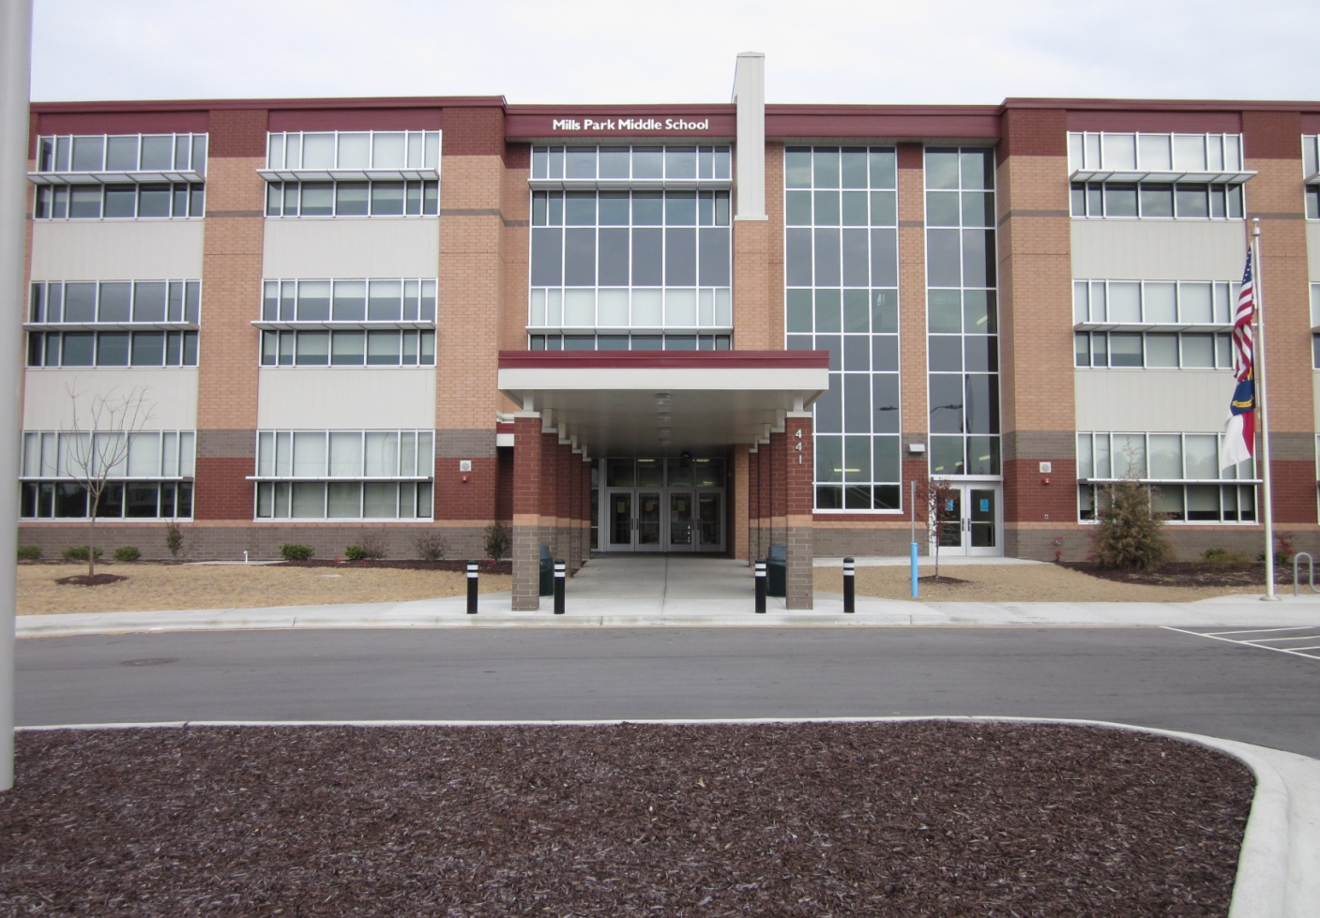
Home of Leopard Pride

Mills Park Middle School
441 Mills Park Drive, Cary, NC 27519

OPEN HOUSE
6:30 p.m.

Wednesday, January 16 (last names beginning with lettersA-M)
Thursday, January 17 (last names beginning with letters N-Z)

Information session and tour for parents of rising 6th graders

Please see our website for more information
http://millsparkms.wcpss.net

